General Product Overview
The Propulsion Condition Monitoring Service (PCMS) is Wärtsilä’s condition monitoring solution for propulsion equipment. It provides the customer with real-time advice and periodic reports concerning the condition of the machinery and information for maintenance planning. With PCMS customers can enhance their installations’ availability, reliability and profitability, whilst reducing risks and the maintenance costs of their assets.

PCMS is applicable to steerable thrusters, transverse thrusters, electric pods, controllable pitch propellers including reduction gears and water jets.

Typical measurements include:
- vibrations,
- lubrication oil contamination
- lubrication oil-water saturation;
- drive shaft RPM
- E-motor load (for E-driven applications)
- control system parameters

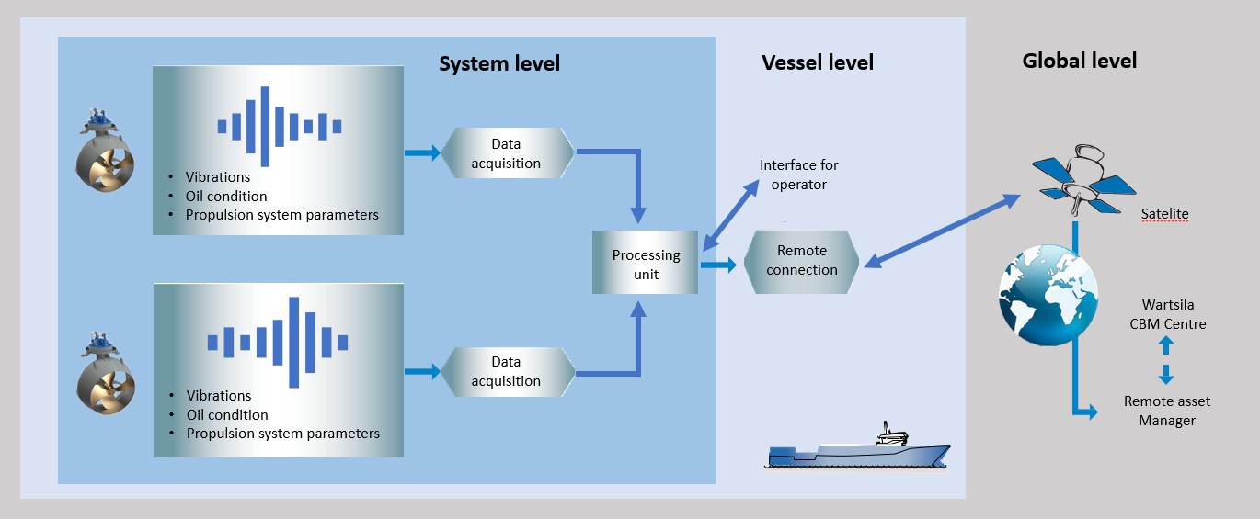
Figure 1 General Layout
Figure 1 shows the general layout of a vessel with two propulsors. Both propulsors are equipped with PCMS sensors. Two propulsors can be connected to one PCMS cabinet. This cabinet acquires and processes data from sensor readings and the propulsion control system for operational parameters. An onboard dashboard allows the operator to view real-time parameters
A data package is generated by the PCMS system. These data packages are transferred to the central server for analysis. PCMS will use the vessels SMTP server to send e-mail automatically. Alternatively, the customer may decide to download the data packages manually and sent them via other means.
Based on central analysis the operator will be provided with a periodic report describing the machinery condition and the operational profile. Analysis is carried out and reported by the Wärtsilä propulsion experts who are ISO18436-2/3 certified in vibration analysis for condition monitoring. Any questions relating to the analysis may be directed to the assigned analyst.

Product Description
PCMS is available for propulsion equipment and rotating equipment.
PCMS for rotating equipment measures only vibrations and shaft rotation speed. Data analysis is done monthly.
PCMS for propulsion also includes control system parameters and optional lubrication oil measurements. By default, the data analysis is done monthly. Optional daily data analysis can be added.
The parameters that are monitored in a PCMS system make it possible to analyse the condition of the propulsion machinery effectively. The following paragraph describes how- and which parameters are monitored. The subsequent paragraphs describe the data analysis, the advisory monitor, and the hardware that is used.

Measurements and monitoring systems

Vibrations
The PCMS cabinet measures vibrations with industrial grade accelerometers. Accelerometers are placed on top of the propulsion machinery, in an x-, y- and z- direction. With this configuration it is possible to measure vibrations in all directions. The accelerometers are sampled continuously and simultaneously at a rate of up to 50,000Hz. When the propulsion machine is driven by an electric motor, this motor can be fitted with accelerometers (four) as well.
The system is configured to collect four types of data from the acceleration measurements. These four data types are described in the table below.
Data type | Range | Resolution | Number of lines
RMS vibration level | 10Hz - 1000Hz | 22 Bit | N.A.
Low frequent spectrum | 0 - 1000Hz | 22 Bit | 2622
High frequent spectrum | 1000 - 10000Hz | 22 Bit | 5898
Envelope spectrum | 0 - 1000Hz | 22 Bit | 2622
Table 1 Vibration data types
Frequency spectra are stored periodically per operating condition, or in the event of irregularities. The PCMS system stores frequency spectra for each operating condition (based on pitch, load and RPM) on a periodic and a triggered basis. If the vibration intensity at one of the frequencies significantly increases an additional spectrum is stored.

Shaft speed
Drive shaft RPM is measured on a flange with an inductive proximity sensor. An accurate RPM measurement makes it possible to correlate frequency spectra to the shaft rotation speed.

Control system interface
Parameters from the propulsion control system are acquired through a MODBUS RTU communication protocol. Table 4 lists control system types that support this connection method.
Type | Platform | Support for communication protocol
UNIC | MCM-11 | Yes
LT7 | Mitsubishi PLC FX2(N) | No (memory full)
 | Mitsubishi PLC FX3UC | Yes
 | Mitsubishi PLC Q | Yes
LT | LMP | Yes
 | MMM | No
 | LMM | No
 | TCU | No
ANCOS | Analogue | No
W | Wichmatic | No
Table 2 Applicability of MODBUS on control system types
An examination in to the applicability of a PCMS system is required on case by case bases when no support for the MODBUS RTU RS422 or RS485 communication protocol is available. In some cases, it is possible to interface using another protocol (in combination with a converter), or the required parameters are measured analogue with a PCMS remote I/O kit.
The following parameters are required from the propulsion control system:
- Load feedback in percent of nominal power (note also paragraph 2.1.4)
- For steerable equipment and rudders:
    - Steering/rudder angle feedback
    - Steering/rudder demand
    - Steering/rudder drive signal (e.g. hydraulic valve drive signal or equivalent)
    - Steering/rudder follow/control-loop failure alarm
- For equipment controllable pitch or bucket angle:
    - Pitch/bucket angle feedback
    - Pitch/bucket demand
    - Pitch/bucket drive signal (e.g. hydraulic valve drive signal or equivalent)
    - Pitch/bucket follow/control-loop failure alarm

Analogue load measurement
In case the load parameter is not available in the propulsion control system it needs to be obtained through an analogue (4-20mA) interface with the variable frequency drive.

Oil measurements
With PCMS lubrication is monitored by measuring the oil water saturation and the oil contamination levels according to ISO4406:2017. In a measurement cycle of a minute the ISO contamination class is measured by an optical transmitter for particle sizes of > 4 μm, > 6 μm, > 14 μm. A PCMS system with oil measurements monitor the lubrication oil in the lower gearbox.

Two solutions are optional available:

- Oil measurement unit equipped with contamination and oil water saturation sensor in the suction line of the pump. Optionally it is also possible to measure water saturation levels and particle sizes in other lubrication circuits, such as the upper gearbox or in the hydraulic steering circuit.
- Only the oil water saturation sensor in the suction line of the pump. Optionally it is also possible to measure water saturation levels and particle sizes in other lubrication circuits, such as the upper gearbox or in the hydraulic steering circuit.

Data analysis

Vibration analysis
Vibration analysis is carried out by propulsion CBM Experts with a degree in engineering who are certified in accordance with ISO18436-2:2003 which describes requirements for training and certification of personnel performing vibration condition monitoring and diagnostics on machines. In the periodic reports and in further communication, faults are normally reported with the aid of vibration spectra such as the one depicted below. CBM Experts take care that for every reported fault also the stage of progression is reported as well as operational and maintenance recommendations.
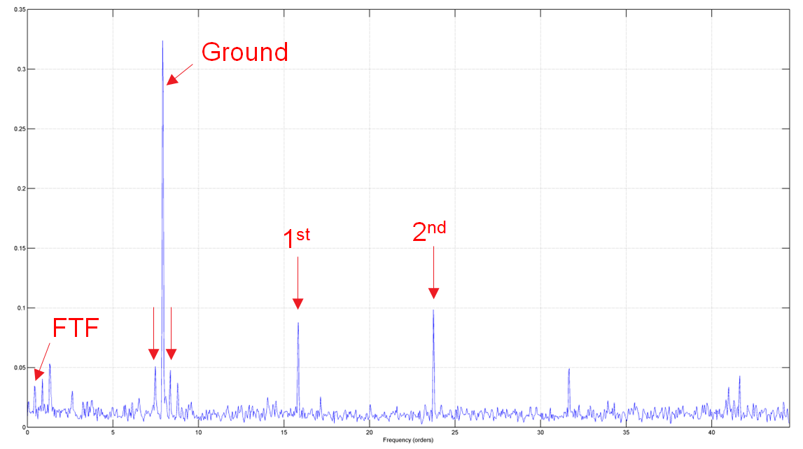
Figure 2 Example of an inner race fault on a roller bearing

The following paragraphs describe how automated vibration analysis and advanced trend analysis support early diagnosis of faults. Further the service level recognitions obtained by the major maritime class societies are described.

Automated vibration analysis
A major part of the vibration analysis is fully automated. The condition of the thruster is monitored accurately by considering all major parameters influencing the vibration signature of a thruster. These may for example be RPM, load and pitch. For each condition (as defined in this multi-dimensional matrix) PCMS remembers the vibration amplitudes at all frequencies in the low-frequent-, high-frequent- and envelope spectrum. In case any of amplitudes rises significantly a state event is triggered upon which the CBM Expert will perform thorough analysis. A high priority is assigned to a state event when it is triggered on a known forcing frequency.

Advanced trend analysis
For propulsion machinery the vibration signature depends on multiple parameters, such as RPM, load and pitch. Contrary to other condition monitoring systems in the market PCMS recognizes this complexity, thereby improving the quality of trend analysis greatly. This is visible in trend plots by a much narrower spread of the data points, as shown in the figure below. A more accurate trend combined with automated detection algorithms ensures the earliest diagnosis of faults possible.
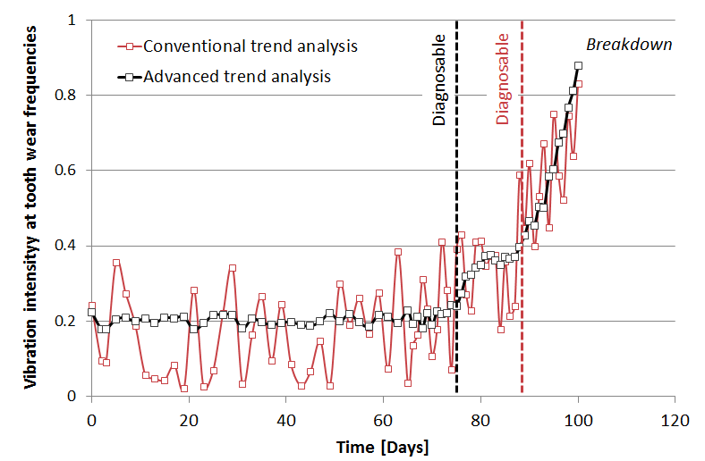
Figure 3 Example of tooth wear progression with conventional- and advanced trend analysis
(this graph is based on real data)

Service level recognition
Traditionally propulsion equipment is overhauled after a certain amount of running hours or calendar time has passed. Thrusters are for example overhauled every five years. This is because on such a traditional maintenance scheme the surveyor requires a periodic (e.g. every 5 years) visual internal inspection of the unit, for which usually dry-docking or underwater removal of the equipment is required. Condition monitoring is intended to replace that obligatory visual internal inspection by an audit of the condition monitoring arrangement. As long as the equipment is in a healthy condition the equipment does not need to be overhauled.

To enter propulsion equipment into a class approved condition-based maintenance arrangement it is required that the related condition monitoring service as provided is recognized by the respective class organization. Wärtsilä Netherlands B.V. is recognized as a condition monitoring service supplier by ABS, Lloyd’s Register, DNV-GL and CCS. The following table contains an overview of these approvals.
Classification Society | Properties
 | Wärtsilä has obtained a certificate of service recognition for the Propulsion Condition Monitoring Service (PCMS). Wärtsilä is authorized to service transverse thrusters, steerable thrusters, electrical pods, CPP installations, reduction gears, electric motors and water jets in a condition-based maintenance scheme. ABS surveyors may rely on the PCMS service to make decisions affecting classification or statutory surveys.
 | Wärtsilä has obtained an approval of service suppliers (in accordance with Lloyds Registers’ procedures for approval of service suppliers) for supplying the Propulsion Condition Monitoring Service (PCMS) to transverse thrusters, steerable thrusters, electrical pods, CPP installations, reduction gears and water jets. LR surveyors may relay on the PCMS service to make decisions affecting classification or statutory services.
 | Wärtsilä has obtained an approval of service suppliers for service suppliers engaged in condition monitoring of machinery on-board mobile offshore units, classed by the society, in accordance with approval programme No. 416 of DNV. The validity of the approval also extents to vessels and is valid for all types of propulsion equipment of all makers.
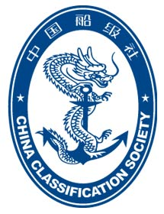 | Wärtsilä has obtained a CCS approval certificate of service supplier and has been audited and is confirmed to be qualified to engage in condition monitoring of propulsion machinery for ships and offshore units, including but not limited to transverse thrusters, electrical pods, CPP installations, reduction gears and water jets.
Table 3 Classification Society recognition of PCMS
Operators are requested to note that although PCMS is a service recognized by class it is still required to enter propulsion equipment in a condition-based maintenance arrangement on a vessel by vessel base. Such a procedure is relatively easy and can be supported with documentation provided by Wärtsilä.

On board dashboard
Optional a on board dashboard can be included which allows the operator to monitor the operating condition of the propulsion machinery on the vessel. The interface shows real-time
This dashboard system is more sophisticated than conventional alarming and monitoring system. PCMS can detect operational states based on real-time comparison of parameters from multiple sources. For example, the vibration measurements can be linked to the operational condition of the vessel.

If the vessel is equipped with multiple condition monitoring systems, the PCMS dashboard will arrange the information accordingly.

E-mail communication to shore
The PCMS system sends data packages one by one via the vessel SMTP server. It is important to check whether the vessels communication dome can send packages. The following items will be requested from the client during the engineering phase:

- Vessel SMTP server IP address or DNS name.
- SMTP port number of this server.
- The username of the e-mail account the PCMS Advisory Monitor will use.
- The password of the e-mail account the PCMS Advisory Monitor will use.

The e-mail account on the vessel’s SMTP server that the PCMS processing unit uses needs to be allowed to send e-mails with attachments of up to 10MB to pcms@wartsila.com)

Wärtsilä Technical Services recommends automatic e-mailing of data packages.

Scope of Supply

Measurements and monitored systems
Table 2 gives an overview of the measurements and monitored systems valid for PCMS.
Source | propulsion | rotating equipment
Vibrations
Three accelerometers mounted in x-, y- and z-direction on top of the propulsion machinery. | included | included
3 accelerometers mounted in x-, y- and z-direction on the Propeller Gearbox (CPP) | optional | excluded
Two accelerometers mounted on the Gearbox PTO shaft | optional | excluded
Four accelerometers mounted on the electric motor for electric driven applications | optional | excluded
Shaft speed
Measures shaft rotation speed with an inductive proximity sensor. | included | included
Lubrication oil contamination
Measures the oil contamination in the gearbox or gear sump | optional | excluded
Measures the oil contamination in the gearbox or gear sump in an additional oil circuit (for example the upper gearbox of a Z-drive steerable thrusters) | optional | excluded
Lubrication oil water saturation
Measures the oil water saturation levels in the gearbox or gear sump | optional | excluded
Measures the oil water saturation levels in the gearbox or gear sump in an additional oil circuit (for example the upper gearbox of a Z-drive steerable thrusters) | optional | excluded
Propulsion system parameters
An interface with the propulsion control system over which operational parameters such as steering angle, pitch, angle RPM and load are gathered. Also acquires lever set points, modes, status indicators, etc. | included | excluded
Analogue load measurement
For electric motor driven applications, the load is acquired from the variable frequency drive as 4-20mA signal. | optional | excluded
Table 4 Measurements and monitored systems

Data Analysis
Table 5 gives an overview of the data analysis activities executed for PCMS. Details about the activities are included in the following paragraphs.
Source | Propulsion | Rotating equipment
Vibration analysis
Vibration / frequency spectra analysis is carried out in accordance with ISO 18436-2. CBM Experts are ISO certified in vibration condition monitoring and diagnostics up to category 3 | included | included
Operational analysis
The main operational parameters of the equipment are analysed to confirm the equipment is operating normally or to detect any abnormalities. When oil measurements are part of scope (the oil contamination and water saturation levels are analysed.  Operational analysis is supported by automated state detection algorithms that support multiple kinds of logic. For example, when the vibration levels increase due to a specific manoeuvre the CBM Expert is alerted of such. Also, in case of for example high oil contamination levels, temperatures or overloads the CBM Expert is alerted. | optional | excluded
Periodic report
Monthly a report is delivered including findings and recommendations made by the CBM Expert, the results of vibration- and oil analysis and a detailed operational profile of the equipment.  When provided with lubrication oil sample analysis reports from a certified laboratory the CBM Expert also cross-references his own findings with those of the laboratory. | included | included
Daily Follow up
PCMS features advanced automated data analysis algorithms that process normal waveform measurements and frequency spectra as they arrive every day. In case abnormal states (e.g. overloads) or a change in vibration signature (e.g. an early roller bearing fault is detected) occur the CBM Expert is alerted and performs thorough analysis the same day. In case abnormalities that deserve immediate attention are detected during the daily analysis the CBM Expert will directly inform the operator. Either through an intermediate report (for more complex issues) or through an e-mail. When daily follow-up is not included these tasks are performed on a monthly base in preparation of the report. | optional | excluded
Table 5 Data analysis activities in PCMS

System components
The hardware that is installed with a condition monitoring system can consists of
- Sensors per propulsion unit.
- one PCMS cabinet for two propulsion units (default) or one PCMS cabinet for one propulsion unit
- one onboard dashboard (optional)

All hardware complies with requirements considered applicable by maritime class societies, considering that PCMS hardware is non-essential equipment. According to ABS 4-8-3/1.5 of the Rules for Building and Classing Steel Vessels a PCMS system belongs to ‘other electrical equipment’ and is to be designed, constructed and tested in accordance with established industrial practices, manufacturer’s specifications and applicable requirements.

PCMS Cabinet
Power Supply | : | 230V – 60 Hz
Analogue Input | : | 20 synchronous channels: 16x vibration, 4x process parameters
Digital inputs | : | 4 optocoupler inputs 0-30V, threshold 3V
Tacho pulse input | : | 2 frequency inputs ±30V DC and AC. Threshold DC 2,5V
Digital output | : | 3 relay changeover contacts, 30 VDC/30VAC/2A
Ethernet | : | 100 Mbit
Environment protection | : | IP65
Dimensions (W x H x D) | : | 600 x 760 x 210 mm
Weight | : | 35 kg
Colour | : | RAL 7035 (Grey)

Accelerometer
Output | : | 3.5mA current line drive with super posed mA signal
Range | : | 0.3 Hz to 10 kHz and 0 to 450 m/s²
Supply | : | 3.5mA current line drive
Environment | : | Operating temperature: -40ºC to 85ºC  Degree of protection: IP65

Inductive proximity sensor
Output | : | Switching (on/off)
Range | : | 0 – 3000 Hz
Supply | : | 24VDC
Environment | : | Operating temperature: -25ºC to 70ºC  Degree of protection: IP67

Oil measurement unit
Output | : | Modbus (TCP/IP) for oil water saturation level  Modbus (TCP/IP) for ISO contamination classes
Range | : | 0-100% for oil water saturation level  ISO 7/6/5 to ISO 28/27/26 according to ISO 4406:1999
Supply | : | 24VDC for transmitters  400 VAC/50Hz or 460VAC/60Hz (through PCMS cabinet) for pump
Environment | : | Operating temperature: -20 ºC to 85 ºC  Degree of protection: IP55

PCMS Remote I/O kit
The PCMS remote I/O kit is used to interface with propulsion control systems that do not support a MODBUS connection. A limited set of important signals is then obtained via analogue or digital signals.

Input | : | 12x Analogue 0-20mA input (12Bit), 2x Analogue, 0-1A AC-DC (12Bit), 12x Digital, 0-24 VDC
Output | : | MODBUS RS422
Supply | : | 100-240Vac 45-65Hz
Size and colour | : | 330x300x200mm (W×H×D); RAL7035
Weight | : | 10 kg
Environment | : | Operating temperature: -15ºC to 55ºC  Storage temperature: -20ºC to 60ºC  Degree of protection: IP 69K

Barbone Linux PC for Dashboard application
Processor | : | Intel Atom Processor x7, series E3950
Memory | : | 4GB
Storage | : | 64 GB
Graphics | : | Intel® HD Graphics 505 Dual display mode supported
Display Interface 1 | : | HDMI 1.4 3840x2160 @30Hz
Display interface 2 | : | Mini DP 1.2 4096x2160 @60Hz
LAN |  | 2x GbE LAN ports (RJ-45) LAN1: Intel I211 GbE controller LAN2: Intel I211 GbE controller. Optional 2 additional LAN ports via FACET.
Wireless |  | Optional WIFI/BT module via FACET
Cellular |  | Optional Cellular modules with FACET integration (4G/GNSS).
USB |  | 2x USB 3.0, 2x USB 2.0
Serial |  | 1x RS232 Serial communication port. Requires a mini serial to DB-9 Male adapter cable - sold separately.
SD | : | Micro-SD slot support SD/SDHC cards Transfer rates up to 25 MB/s
Input Voltage | : | Unregulated 7 – 20VDC input
Dimensions (W x H x D) | : | 112 x 84 x 34 mm
Weight | : | 0,35 kg

Installation and commissioning
Installation of PCMS is not included in PCMS, this is yard/owner delivery. Commissioning of PCMS by a Wärtsilä service engineer is required and can be included in the sales price.

During the installation of a PCMS system, the Wärtsilä service engineer supervises all activities. He is responsible to notice possible deficiencies in manuals or complains from subcontractors or other involved parties. At the end of the installation a service report is created which contains an historic overview of all activities and remarks.

Site requirements
Requirements related to the installation of PCMS hardware can be found in document DBAC982200 “PCMS Hardware Guide”.

Health, Safety and Environmental specifications
All hardware is CE marked, and either type approved or thoroughly tested by Wärtsilä. Internal conductors and cable ducts in the cabinets are halogen free, low smoke and in accordance with IEC 61892 and IEC 60332

All critical components including components that interface with third party systems are type approved and in accordance with IEC60533.

For installation and commissioning activities the Field Services EHS guidelines are applicable.

Ordering instructions
PCMS can be sold as stand-alone agreement or be included in a larger service agreement.

For both scenario’s PSS Propulsion Sales Support (AMS from 01-01-2019 onwards) is responsible for providing the required sales support including:

- Provide sales support to the area companies, product sales, agreement sales and Marine Business sales in new build.
- Discuss with Projects Centre Services NL a realistic delivery time.
- Arrange an onboard inspection to be carried out.
- Create the sales order and the project (project builder) in SAP when the project is sold.
- Arrange a project kick-off meeting with Project Centre.

Offering creation
For the creation of an offer, a PCMS offer tool is available for PSS Sales Support. With the offer tool, the scope of supply is specified, cost is calculated, and an offer is automatically generated as word file. The offer is sent to the offering organisation or person.

Contract
In the offering catalogue a link is available to a PCMS contract template in word. The PCMS contract price can be based on:

Contract based on CAPEX and OPEX
- Payment of the PCMS CAPEX cost at delivery
The CAPEX cost includes cost for hardware, engineering and commissioning, but excludes the monthly analysis cost.
- Monthly payment of a fee for the analysis (OPEX)

Contract based on OPEX
Monthly payment of a service fee that includes all PCMS cost.
The prices for the equipment, hardware and parts are included in the above-mentioned service fee.

